EXPERIMENT- 3
1.# Employee Data
employee <- c("Emp1", "Emp2", "Emp3", "Emp4", "Emp5")
performance <- c(85, 92, 78, 90, 76)
# Line Chart
plot(performance,
type = "o",
xaxt = "n",
col = "blue",
pch = 16,
xlab = "Employees",
ylab = "Performance Score",
main = "Employee Performance Trend")
axis(1, at = 1:5, labels = employee)
grid()
legend("bottomleft",
legend = "Performance",
col = "blue",
lty = 1,
pch = 16)

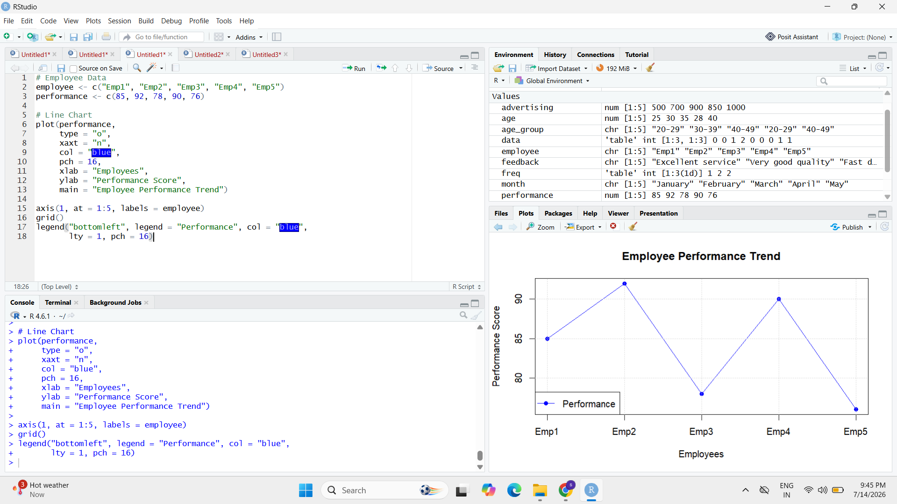

2.# Department Data
department <- c("Sales", "HR", "Marketing", "Sales", "HR")

# Count Employees
dept_count <- table(department)

# Bar Chart
barplot(dept_count,
col = "orange",
xlab = "Department",
ylab = "Number of Employees",
main = "Employee Distribution by Department")

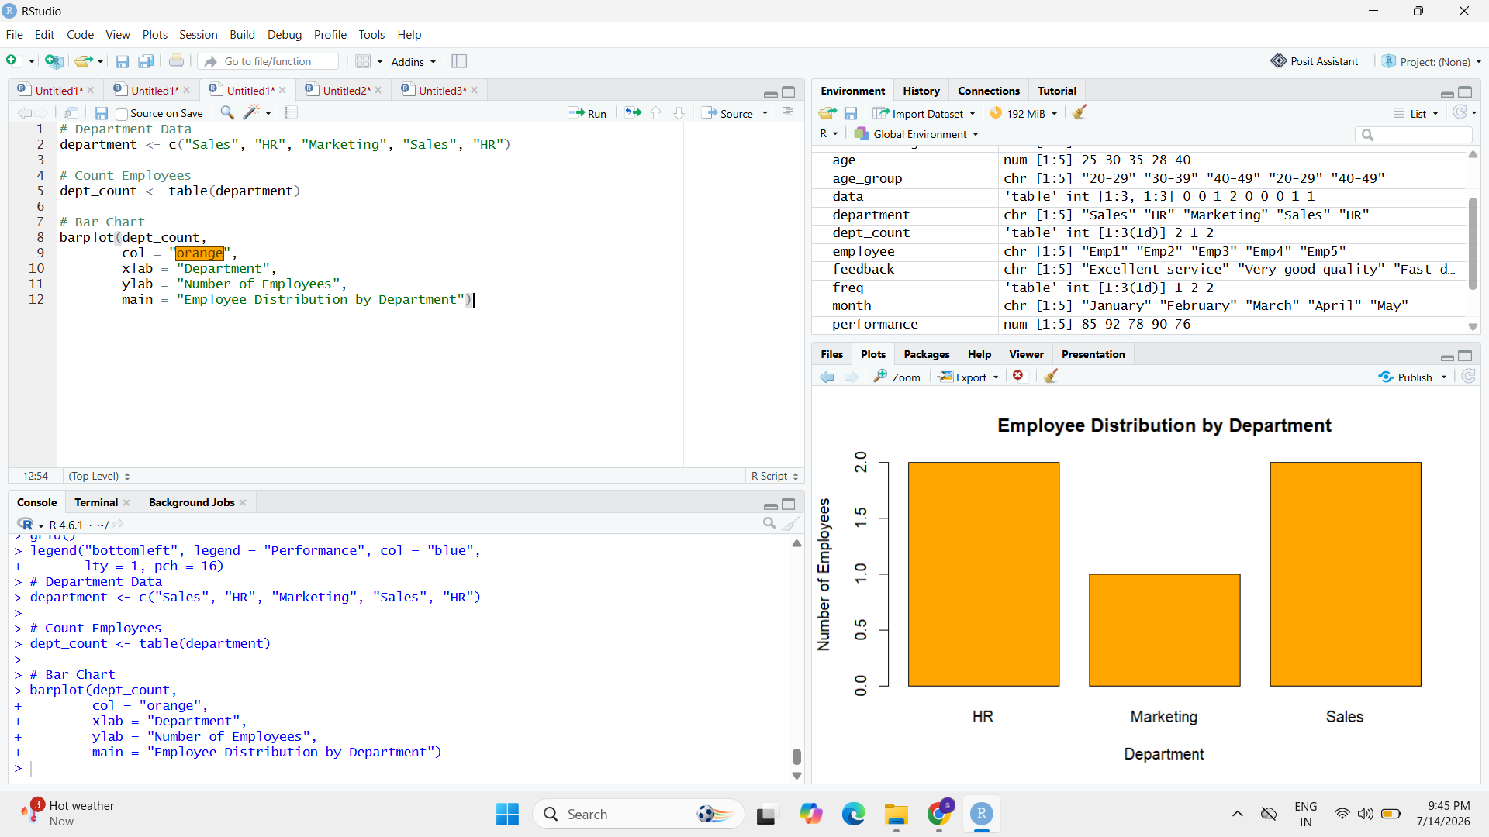

3. # Data
years <- c(5, 3, 7, 4, 2)
performance <- c(85, 92, 78, 90, 76)

# Scatter Plot
plot(years,
performance,
pch = 19,
col = "red",
xlab = "Years of Service",
ylab = "Performance Score",
main = "Years of Service vs Performance")

# Regression Line
abline(lm(performance ~ years),
col = "blue",
lwd = 2)
